  - Team Run SJQ
  - Basketball

Team RUN SJQ LIONS JORDAN hitting a 3 pointer |  | Issue # 2 December 14th 2013
Game at Junior High 72
Team Run SJQ Lions had a game on Saturday December 14th at Junior high school 72 on Guy Brewer Blvd. The team they were facing had a big center that coach Gil thought was going to be a factor against Team Run’s smaller center. The game started off with Josh taking the ball the length of the court strong to the basket to score. Josh would be the glue down low for team run. He gave the big center problems on defense and took him out of the game early by going to the basket strong and getting him into foul trouble.
The way Josh was playing I don’t think it would have mattered if he was in the game anyway. He was taking everyone to the basket with authority and helped Team Run get out to a lead in the first half. Once again it wasn’t a one player victory with Josh doing his job down low some of the other player helped with the onslaught of points.
Point Guard Naja Felon
Naja Felon took over the game in the middle of the first half with her tenacious defense on their point guards. She stole the ball twice and went the length of the court for easy layups. She went to the basket at will and was fouled several times. She went to the line with confidence and drained all her free throws. She was all over the court with her hustle that when she would get into her defensive stance the other team was intimidated. One time their point guard was coming up court and you could hear coach Todd say “Naja you ready? You ready?... take it”. And she did for another steal and an easy 2 points. She was so amazing on defense that one play she made the guard throw it to where she wanted and stole it.
There was another Team Run player that would shine on this night. His name is Jordan smith. Jordan would have some highlights of his own that would bring the packed gym to their feet. One of the high lights First he would receive a pass on the wing behind the 3 point line and with no hesitation and perfect for

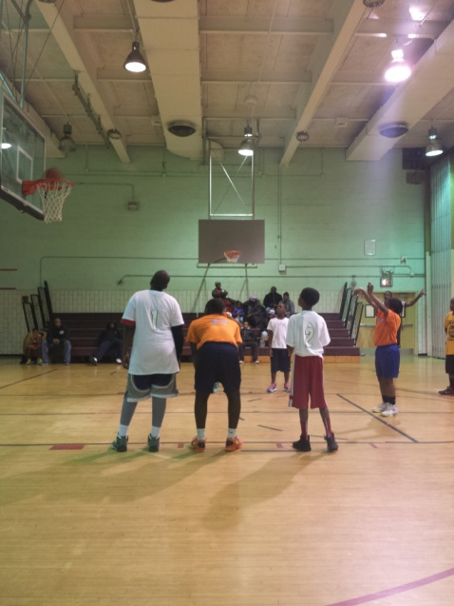

Point Guard Naja Felon Draining a free Throw

